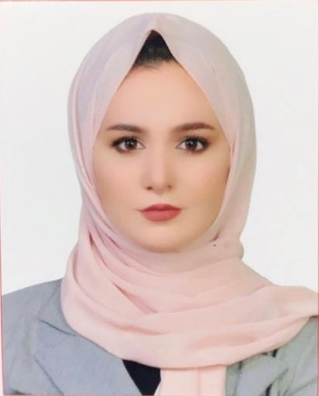

Curriculum Vitae

***Personal Information:***

**Name**: Shahad Nidhal

**Last Name**: Altaee

**Date of birth**: 14/11/1996

**Nationality**: Iraqi

**Passport Number**: A9697379

**Permanent address**: Almaqal/Al-Basra, Iraq.

**Telephone**: +9647725527750. **Email address**: **shahadnedal9@gmail.com**

***Strength & Skills***

Highly skilled and knowledgeable Biologist with good experience in blood drawing and in Chemical laboratory analysis and. Strong multitasker with exceptional skill in functioning well in a high-pressure work environment.

I have no problem with taking on additional tasks and am always willing to advise others. I can handle high pressure environments with ease and open mind and a good team player.

***Education information***

2014-2018: B. Sc. Biology Science, at University of Basra

• Major subjects:

• Immunology

• Microbiology

• Biotechnology

• Medical bacteria

• Biochemistry

• Physiology

• Medical mycology

• Parasitology

• Virology

• Haematology

• Histology

• Cytology

• Serology

• Clinical chemistry

***Work experience***

* Worked as a volunteer in the emergency laboratory at Al Sadar Altalimi Hospital for one month in 2018.
* Trainer for two months in AlMwani Hospital in 2018.
* Office coordinator and recipient in **Tafa3ul Agency.** 2019/2/1-till now.

**COMPUTER SKILLS AND COMPETENCES**

I possess strong command over Microsoft office (Word, Excel, PowerPoint, Outlook)

**Languages:**

Arabic (Written and Spoken) - First language, English (Written and Spoken) - Second Language.